**Model free Policy Iteration to DQN**

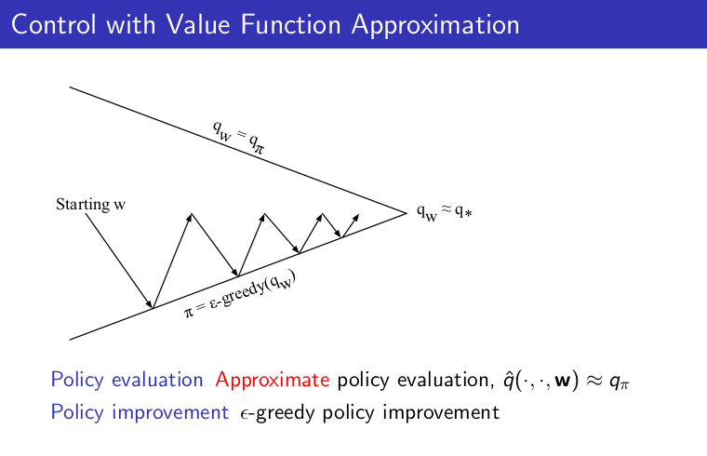

Example of a very model free Policy-Iteration Algorithm:

SARSA ALGORITHM:

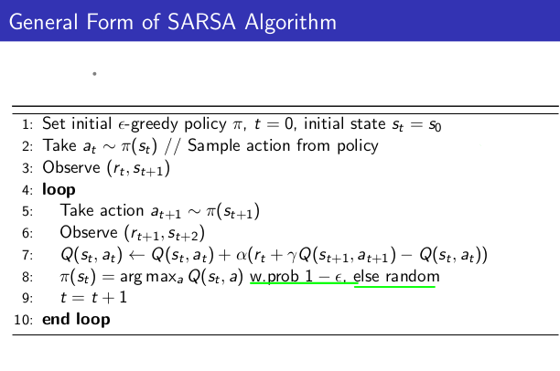

SARSA is ON policy learning , estimates the value of current behavior policy and then updates the policy trying to estimate.

Other Option is of OFF-POLICY LEARNING where we can directly estimate the value

of optimal_policy while acting another behavior policy pi_b which can also explore all possible states .

Can we omit the Policy improvement step? YES

**Q-LEARNING**

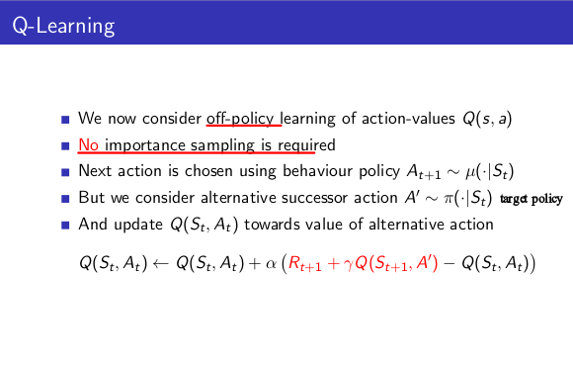

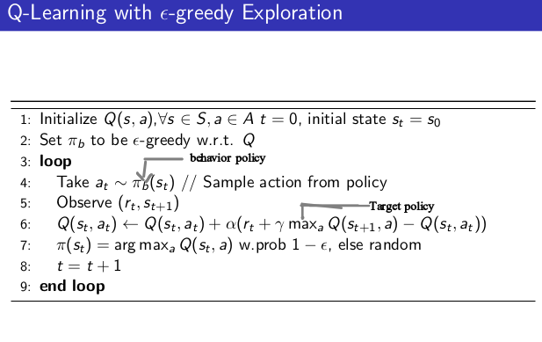

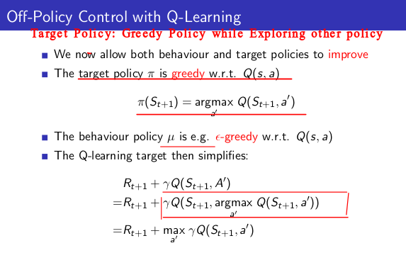

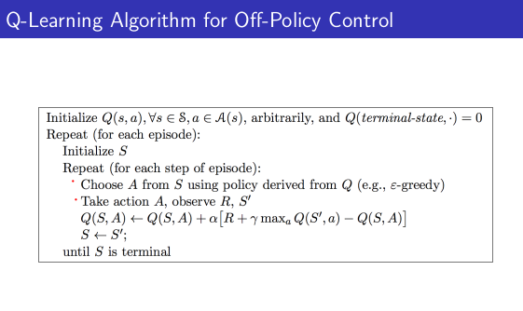

Essence : Updating the Q values in the direction of best possible next Q values

Value Iteration->Fitted Value Iteration ->Fitted Q Value Iteration( for unkown dynamics)

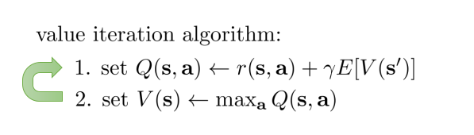

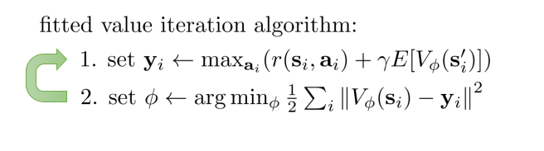

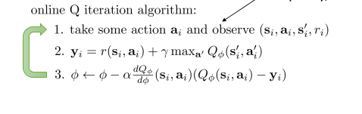

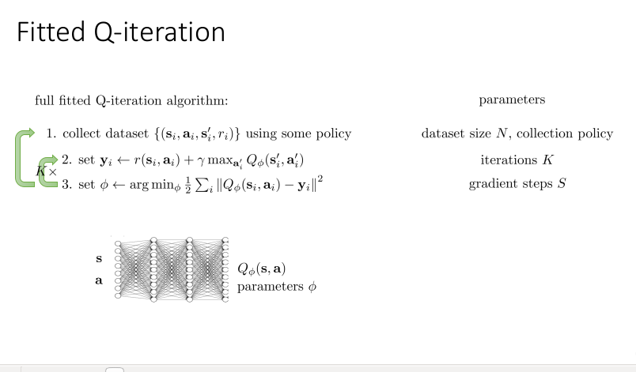

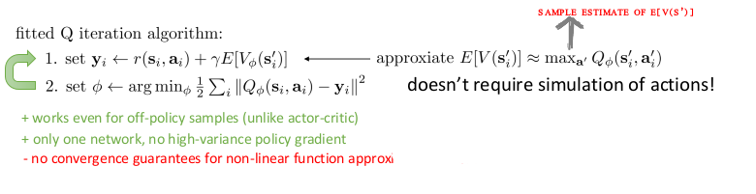

Fitted Q learning is off policy learning , where data can be come from any policy and the final policy that we are trying to learn is arg max policy .

**Q-learning** which is an online policy :is a special case of Fitted-Q iteration where K=1



This Q learning algorithm does not converge in practice , there is two problem with this

a. Correlated data

b.non stationary target value

These are fixed by replay buffers, using mini – batch gradient descent and using target networks.

DQN algorithm is improved , stable algorithm for fitted Q learning algorithm consist of above changes:

DEEP Q- LEARNING ALGORITHM (DQN):

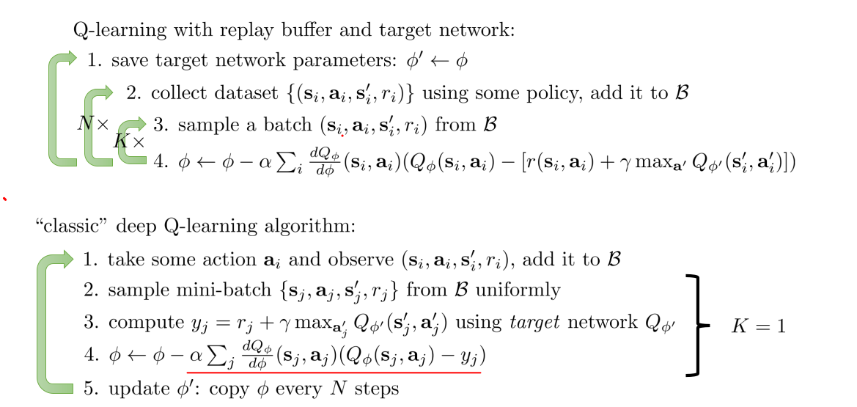

Double DEEP Q-LEARNING ALGORITHM:

In some stochastic environments the well-known reinforcement learning algorithm Q-learning performs very poorly. This poor performance is caused by large overestimations of action values. These overestimations result from a positive bias that is introduced because Q-learning uses the maximum action value as an approximation for the maximum expected action value.introducing an alternative way to approximate the maximum expected value for any set of random variables. The obtained double estimator method is shown to sometimes underestimate rather than overestimate the maximum expected value. We apply the double estimator to Q-learning to construct Double Q-learning, a new off-policy reinforcement learning algorithm.New algorithm converges to the optimal policy and that it performs well in some settings in which Q-learning performs poorly due to its overestimation.

To modify the DQN one way to use the current and target networks:

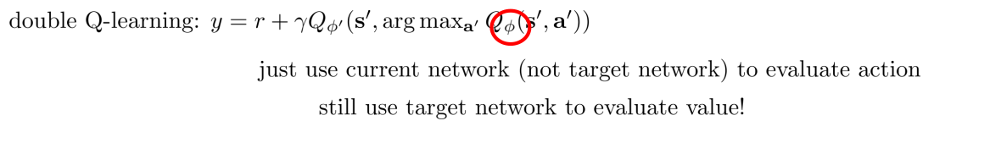

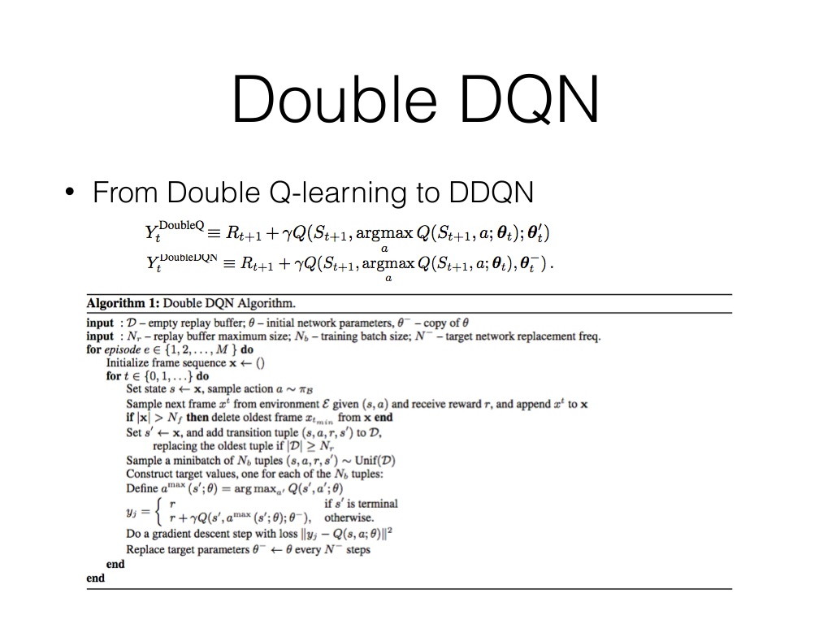

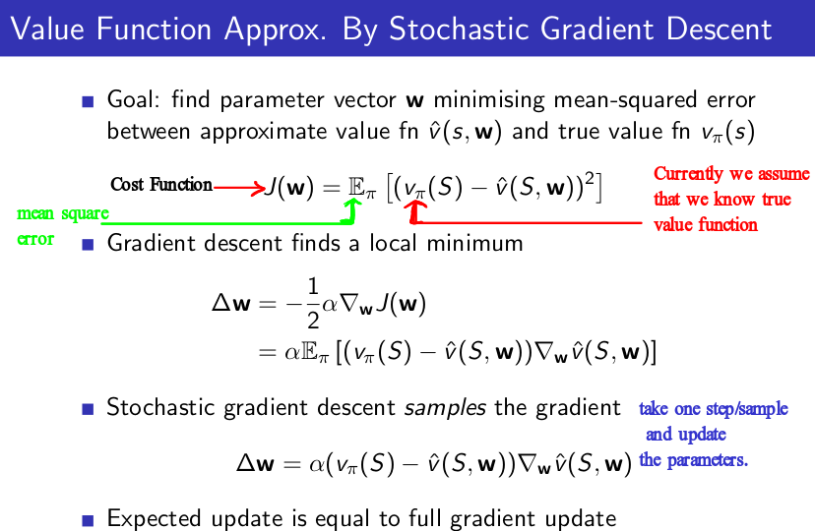

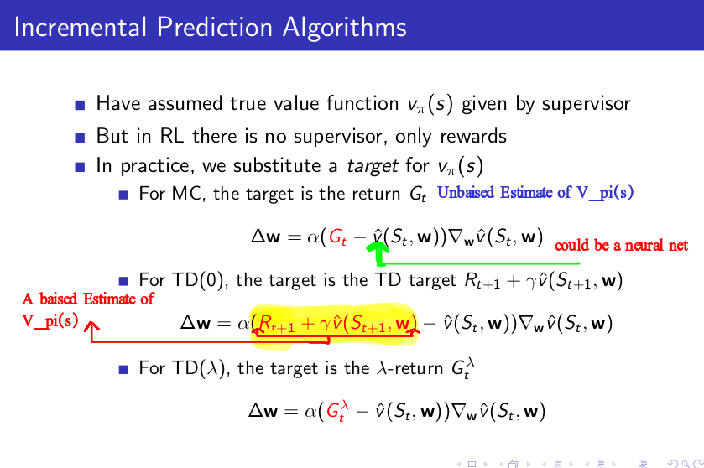

In general when there is linear function estimator function to estimate the Value function the stochastic gradient desecent with TD(0) converge, but when we move towards the non linear function approximation with TD(0) Bootstrap this method does not converge theoritically as well as in practice.